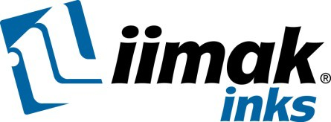 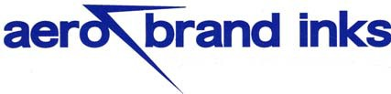

American Marking Inc

2435 Vale Drive

Birmingham, Al 35244

Phone: (Tn): 423-843-0446 or (Al): 205-987-0151

Website: www.americanmarking.com

***Specialty Inks for Hard to Mark Surfaces***

**Product Specification AERO 1226**

|  |  |
| --- | --- |
| IIMAK Product Category | Non Standard |
| General Description | Fast drying speciality marking ink engineered for use on a wide variety of non-porous surfaces. Most commonly applied by hand stamp, or can be used in a wide variety of automatic coders. |
| System | Solvent |
| Colors | Black, White*  Custom Colors (MOQ may apply): Blue, Gray, Brown, Purple Color matching available |
| Sizes Available | Quart, Gallon (call for additional sizes) |
| Colorant | Dye |
| Surface Type | Non-porous |
| Typical Substrates | Non-porous metal, plastic, polyethylene, mylar, electronic, parts, cellophane |
| Suggested Printing Method | All types of automatic coders, hand stamp |
| Regulatory / Certifications | REACH, RoHS, HAPS Free  Conforms to U.S. Govt. Spec. TT-I-1795A Type I, and Spec. AA-208 |
| Dry Time | 10-15 seconds |
| Recommended Reactivator Thinner / Cleaner / Solvent | 1250 Solvent/Reactivator  Contact IIMAK Inks for mixing ratios to alter dry times if needed. |
| Shelf Life (Unopened Container) | Dye - 12 months / Pigment - 6-9 months |

*Pigment September 2013

Data provided is for reference only, testing of ink in your application is recommended. For more information, please contact IIMAK Inks or refer to Safety Data Sheet.